SIMATS ENGINEERING
ASSESSMENT TOOL 3
COURSE NAME | INTERNET PROGRAMMING
COURSE CODE | CSA43
NAME | K VENKATA SIVA PRASAD
REGISTER NUMBER | 192325106

COURSE OUTCOME COVERED
CO-1: Develop well-structured, standards-compliant web pages using HTML/XHTML and XML, and apply Internet protocols and HTTP communication mechanisms for web content delivery. (L2)
Assessment Tool: Case Study Weightage: 10%

QUESTIONS
Scenario: Web Development Standards Implementation. A startup is developing a modern web application. During development, the team encounters multiple issues related to HTML elements, HTTP methods, XML syntax and web communication protocols. The following observations are made:
- The team needs to embed a promotional video on the homepage.
- A registration form must securely send user data to the server.
- The navigation menu must follow semantic HTML standards.
- XML configuration files are being used but contain syntax errors.
- The application must communicate over the correct web protocol.
Data Snippets Provided
Snippet 1: Video embedding options
Option | Code
A | <media src="video.mp4"></media>
B | <video src="video.mp4" controls></video>
C | <movie src="video.mp4"></movie>
D | <vid src="video.mp4"></vid>

Snippet 2: Form submission methods
Option | Method
A | GET
B | POST
C | PUT
D | DELETE

Snippet 3: Navigation elements
Option | Element
A | <div>
B | <nav>
C | <section>
D | <header>

Snippet 4: XML syntax
Option | Code
A | <note><to>User</to><from>Admin</from>
B | <note><to>User</to><from>Admin</from></note>
C | <note><to>User</from></note>
D | <note to="User"></note

Snippet 5: Web communication protocols
Option | Protocol
A | FTP
B | HTTP
C | SMTP
D | SNMP

Questions
1. Select the correct HTML tag for video embedding and justify your answer.
2. Identify the appropriate HTTP method for form submission and explain why.
3. Choose the proper semantic element for navigation and justify its usage.
4. Identify the correct XML syntax and explain the error in other options.
5. Choose the correct protocol for web communication and justify your choice.

SOLUTION

1. Select the correct HTML tag for video embedding
Answer: Option B – <video src="video.mp4" controls></video>
HTML5 introduced the <video> element so that a video can be played directly inside a web page by the browser itself, without Flash or any other external plug-in. It is the only valid element among the four snippets, which is why the promotional video on the homepage must be embedded with it. Because it is a standard element, it works in all modern browsers (Chrome, Edge, Firefox, Safari) on desktop and mobile.
Important attributes used
- src – gives the location (URL) of the video file, here video.mp4.
- controls – shows the browser’s built-in play/pause button, volume control, seek bar and full-screen button. Without it the visitor cannot start the video.
- width / poster / preload – width sets the display size, poster shows a preview image before playing, and preload="none" avoids downloading the file until the user presses play, which saves bandwidth.
- Fallback content – any text or link placed between the opening and closing tags is displayed only by browsers that do not support the element.
Why the other options are wrong
Option | Tag | Reason
A | <media> | Not defined in HTML5. The browser treats it as an unknown element and shows nothing.
B | <video> | Correct. Standard HTML5 element for embedding video.
C | <movie> | Not a valid HTML element; it was never part of any HTML standard.
D | <vid> | An invented short name. It is not in the specification, so no player is created.

HTML CODE:
<!DOCTYPE html>
<html lang="en">
<head>
<meta charset="UTF-8">
<meta name="viewport" content="width=device-width, initial-scale=1.0">
<title>Promotional Video</title>
</head>
<body>
<h1>Welcome to Our Startup</h1>
<video src="video.mp4" controls width="480" poster="promo-poster.jpg" preload="none">
Your browser does not support the video tag.
<a href="video.mp4">Download the video</a> instead.
</video>
</body>
</html>
OUTPUT:

Figure 1: Page with the embedded video player and controls

2. Identify the appropriate HTTP method for form submission
Answer: Option B – POST
A registration form collects personal data such as a name, an e-mail address and a password. With the POST method the browser places this data in the body of the HTTP request, not in the URL. This keeps sensitive values out of the address bar, browser history, bookmarks and server access logs, and there is no practical limit on the amount of data sent.
Feature | GET | POST
Where data is sent | Appended to URL as query string | Inside the request body
Visibility | Visible in URL, history and logs | Not shown in the URL
Data size | Limited by URL length | No practical limit
Purpose | Retrieve data (safe, repeatable) | Create or change data on server
Suitable for registration? | No | Yes

- PUT and DELETE replace and remove resources in REST APIs. HTML forms support only GET and POST in the method attribute, so these two cannot be used here.
- POST alone is not encryption. To send the data securely the site must also use HTTPS (TLS). On the server the password should be hashed (for example with bcrypt) before it is stored, and a CSRF token should protect the form.
HTML CODE:
<!DOCTYPE html>
<html lang="en">
<head>
<meta charset="UTF-8">
<title>User Registration</title>
<style>
body { font-family: Arial, sans-serif; margin: 20px; }
form { width: 320px; padding: 16px; border: 1px solid #999; border-radius: 6px; }
label { display: block; margin-top: 10px; }
input { width: 100%; padding: 6px; box-sizing: border-box; }
button { margin-top: 14px; padding: 8px 18px; }
</style>
</head>
<body>
<h1>User Registration</h1>
<form action="/register" method="POST">
<label for="name">Name:</label>
<input type="text" id="name" name="name" required>

<label for="email">Email:</label>
<input type="email" id="email" name="email" required>

<label for="pwd">Password:</label>
<input type="password" id="pwd" name="password" minlength="8" required>

<button type="submit">Register</button>
</form>
</body>
</html>
The attribute method="POST" selects the POST method, action="/register" names the server resource that receives the data, required and type="email" give basic validation in the browser, and type="password" hides the typed characters.
OUTPUT:
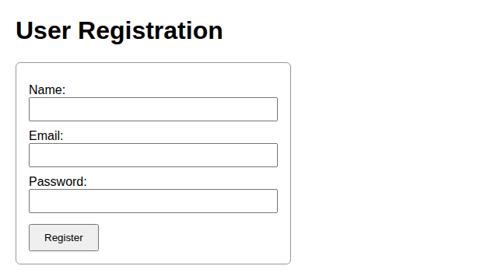
Figure 2: User registration form

3. Choose the proper semantic element for navigation
Answer: Option B – <nav>
The <nav> element is the HTML5 semantic element for a block of major navigation links such as the main menu. It tells browsers, search engines and assistive technologies that the links inside are used to move around the site. Semantic elements describe the meaning of content, not just its appearance.
- Accessibility: screen readers announce <nav> as a navigation landmark, so users can jump straight to the menu or skip it.
- Readable, maintainable code: the markup states its own purpose, so developers understand the page structure quickly.
- Search engine optimisation: crawlers can identify the main site links and understand how the pages are connected.
Option | Element | Why it is or is not suitable
A | <div> | Generic container with no meaning; it does not follow semantic standards.
B | <nav> | Correct. Represents a section of navigation links.
C | <section> | Groups related content under a heading; it does not mean navigation.
D | <header> | Holds introductory content such as a logo or title. It may contain a <nav>, but it is not itself navigation.

HTML CODE:
<!DOCTYPE html>
<html lang="en">
<head>
<meta charset="UTF-8">
<title>Startup Home</title>
<style>
body { font-family: Arial, sans-serif; margin: 0; }
header { background: #1b2a49; color: #fff; padding: 14px 24px; }
nav ul { list-style: none; margin: 0; padding: 0; display: flex; background: #e8eef7; }
nav a { display: block; padding: 12px 22px; text-decoration: none; color: #1b2a49; }
nav a:hover { background: #f2a33a; }
</style>
</head>
<body>
<header>
<h1>Startup Home</h1>
</header>
<nav aria-label="Main navigation">
<ul>
<li><a href="index.html">Home</a></li>
<li><a href="about.html">About</a></li>
<li><a href="services.html">Services</a></li>
<li><a href="contact.html">Contact</a></li>
</ul>
</nav>
</body>
</html>
The links are placed in an unordered list (<ul>) inside <nav>, which is the recommended pattern; CSS turns the list into a horizontal menu. The aria-label gives the landmark a clear name for screen readers.
OUTPUT:

Figure 3: Header with semantic navigation menu

4. Identify the correct XML syntax and explain the error in other options
Answer: Option B – <note><to>User</to><from>Admin</from></note>
Option B is a well-formed XML document: it has exactly one root element (<note>), every start tag has a matching end tag with the same spelling and case, and the elements are properly nested. A well-formed document can be read by any XML parser. The errors in the other options are explained below.
Option | Code | Error
A | <note><to>User</to><from>Admin</from> | The root element <note> is never closed because the end tag </note> is missing.
B | <note><to>User</to><from>Admin</from></note> | No error. Well-formed.
C | <note><to>User</from></note> | Mismatched tags: <to> is closed by </from>, and <from> was never opened. End tags must match start tags exactly.
D | <note to="User"></note | The end tag is incomplete: </note has no closing > symbol, so the element is not properly terminated.

Rules of well-formed XML
- The document must have a single root element.
- Every start tag must have a matching end tag (or be self-closing, such as <item/>).
- Elements must be properly nested; they cannot overlap.
- Tag and attribute names are case-sensitive (<Note> is different from <note>).
- Attribute values must always be enclosed in quotes.
- Special characters such as < and & must be written as &lt; and &amp;.
XML CODE:
<?xml version="1.0" encoding="UTF-8"?>
<note>
<to>User</to>
<from>Admin</from>
</note>
OUTPUT:
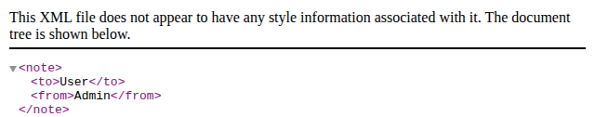
Figure 4: Well-formed XML (Option B) displayed as a document tree
When Option A is opened in the browser, the XML parser stops and reports an error, which confirms that the document is not well-formed:
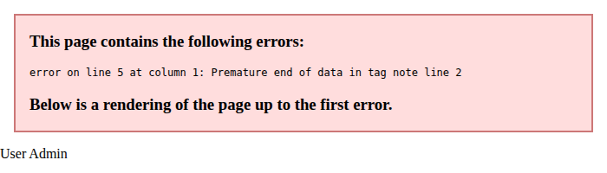
Figure 5: Parser error for the malformed XML of Option A

5. Choose the correct protocol for web communication
Answer: Option B – HTTP (Hypertext Transfer Protocol)
HTTP is the application-layer protocol that web browsers and web servers use to exchange web content such as HTML pages, images, videos and form data. It follows the client–server request/response model: the browser sends an HTTP request, and the server returns an HTTP response containing a status code and the requested content. HTTP normally runs over TCP on port 80 and is stateless, meaning each request is handled independently.
Option | Protocol | Port | Purpose and reason it is not correct
A | FTP | 21 | Transfers files between computers; it does not deliver web pages to a browser.
B | HTTP | 80 | Correct. Delivers web pages and carries form data between browser and server.
C | SMTP | 25 | Sends e-mail between mail servers.
D | SNMP | 161 | Monitors and manages network devices such as routers and switches.

- Use HTTPS in practice. Because the application handles registration data, it must use HTTPS (HTTP over TLS/SSL, port 443). HTTPS encrypts the traffic, authenticates the server with a certificate and prevents tampering.
- Common status codes: 200 OK (success), 301 Moved Permanently (redirect), 404 Not Found (missing page) and 500 Internal Server Error (server fault).
OUTPUT (HTTP request and response cycle):
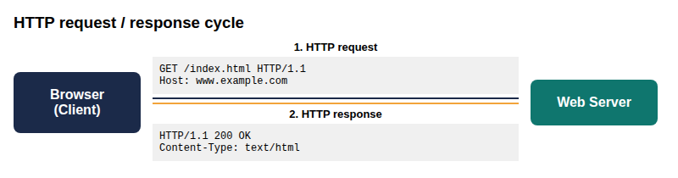
Figure 6: Browser–server communication using HTTP

SUMMARY OF ANSWERS
Q. No. | Answer | Key reason
1 | B – <video> | Standard HTML5 element; no plug-in needed
2 | B – POST | Sends data in the request body, not in the URL
3 | B – <nav> | Semantic landmark for navigation links
4 | B – <note>…</note> | Single root, matching end tags, proper nesting
5 | B – HTTP (HTTPS) | Protocol for web request and response

Thus, using the video element, the POST method, the nav element, well-formed XML and HTTP/HTTPS together helps the startup build a standards-compliant, accessible and reliable web application.

Code of Conduct:
I K VENKATA SIVA PRASAD 192325106 certify that this submission is my original work and that I have adhered to the guidelines specified for this assessment. I understand that any violation of academic integrity rules will result in disciplinary action.

Signature of the student: K VENKATA SIVA PRASAD

